 | 12.1.46 Editors - Geometry Nodes Editor - Header - Add Menu - Utilities - Field
Table of content
Detailed table of content 1
Add menu - Utilities - Field 3
Accumulate Field 3
Evaluate at Index 4
Evaluate on Domain 5
Field Average 5
Field Min & Max 6
Field Variance 7

Detailed table of content
Detailed table of content
Detailed table of content 1
Add menu - Utilities - Field 3
Accumulate Field 3
Inputs 3
Value 3
Group Index 3
Properties 3
Data Type 3
Outputs 4
Leading and Trailing 4
Total 4
Evaluate at Index 4
Inputs 4
Index 4
Value 4
Properties 4
Data Type 4
Domain 4
Output 4
Value 4
Evaluate on Domain 5
Inputs 5
Value 5
Properties 5
Data Type 5
Domain 5
Outputs 5
Value 5
Field Average 5
Inputs 5
Value 5
Group ID 6
Properties 6
Data Type 6
Domain 6
Outputs 6
Mean 6
Median 6
Field Min & Max 6
Inputs 6
Value 6
Group ID 6
Properties 6
Data Type 6
Domain 7
Outputs 7
Min 7
Max 7
Field Variance 7
Inputs 7
Value 7
Group ID 7
Properties 7
Data Type 7
Domain 7
Outputs 8
Standard derivation 8
Variance 8

Add menu - Utilities - Field
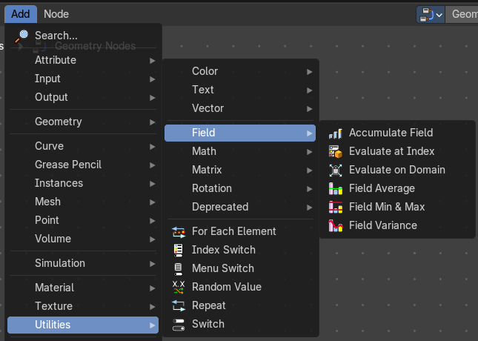
Field nodes.

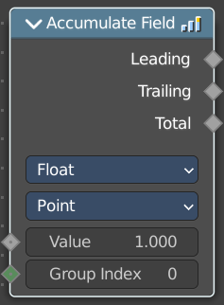
Accumulate Field
Creates a running total of a given Vector, Float, or Int field.

Inputs

Value
The field to be accumulated.

Group Index
The values of this input are used to aggregate the input into separate 'bins', creating multiple accumulations.

Properties

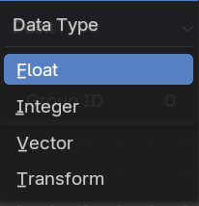
Data Type
What data type to work with.

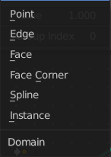
Domain
From which domain to use the data.

Outputs

Leading and Trailing
Returns the running totals starting at either the first value of each accumulations or 0 if there is no data

Total
Returns the total accumulation at all positions of the field.

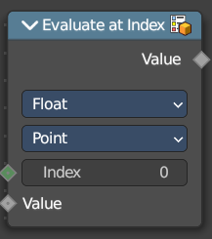
Evaluate at Index
This node allows accessing data of other elements in the context geometry.
It is similar to the Transfer Attribute node in Index mode. The main difference
is that this node does not require a geometry input, because the context
is used.

Inputs

Index
Input Index.

Value
Input Value.

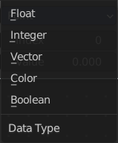
Properties

Data Type
What data type to calculate.

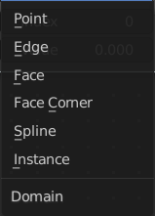
Domain
What geometry to calculate.

Output

Value
The output value.

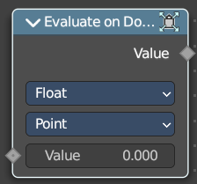
Evaluate on Domain
This node evaluates an existing field on a separate domain in a larger field context - an alternative to the Capture Attribute node. This nodes gets the field type of an existing field from the input socket and interpolates the field type as an array in the output socket.

Inputs

Value
The input value to get the field.

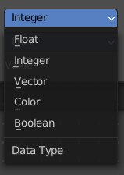
Properties

Data Type
Select the Data Type - which can be float, integer, vector, color and boolean.

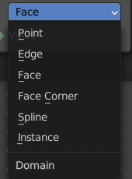
Domain
The domain the Field evaluates. This gets and filters the field type. The domain can be point, edge, face, face corner, spline or instance.

Outputs

Value
The output value.

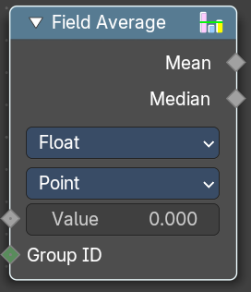
Field Average
Calculate the mean and median of a given field.

Inputs

Value
The input value to get the field.

Group ID
The input Group ID to get the field.

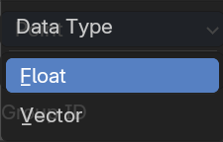
Properties

Data Type
Select the Data Type - which can be float, integer, vector, color and boolean.

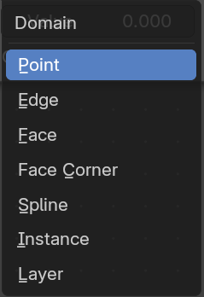
Domain
The domain the Field evaluates. This gets and filters the field type. The domain can be point, edge, face, face corner, spline or instance.

Outputs

Mean
The Mean output value.

Median
The Median output value.

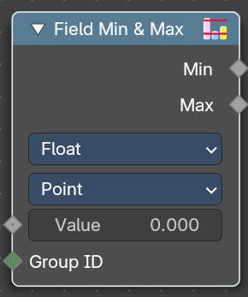
Field Min & Max
Calculate the minimum and maximum of a given field.

Inputs

Value
The input value to get the field.

Group ID
The input Group ID to get the field.

Properties

Data Type
Select the Data Type - which can be float, integer, vector, color and boolean.

Domain
The domain the Field evaluates. This gets and filters the field type. The domain can be point, edge, face, face corner, spline or instance.

Outputs

Min
The Min output value.

Max
The Max output value.

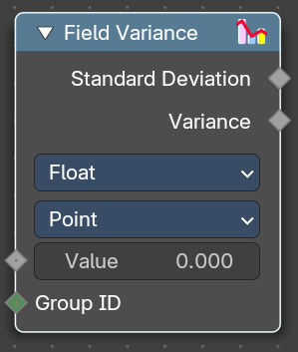
Field Variance
Calculate the standard derivation and variance of a given field.

Inputs

Value
The input value to get the field.

Group ID
The input Group ID to get the field.

Properties

Data Type
Select the Data Type - which can be float, integer, vector, color and boolean.

Domain
The domain the Field evaluates. This gets and filters the field type. The domain can be point, edge, face, face corner, spline or instance.

Outputs

Standard derivation
The Min output value.

Variance
The Max output value.

